September 3rd, 2006
Hi
There is very little to write about this week. Fortunately, while I was getting ready to write, the radio news was on and that enabled me to add one or two additional things.
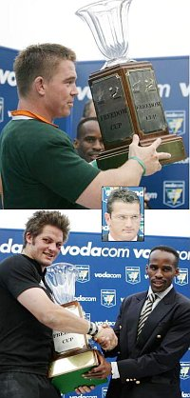
Swam three times again this week and did a total of 8 km, which averages at just over 2.8 km per swim. Not bad! But as there has been no heavy rain, the water is still hot. On Friday, it was 33⁰C. And now that schools are back, having started on September 1st (a Friday!) I might be able to get back to using the main part of the pool and longer lengths.
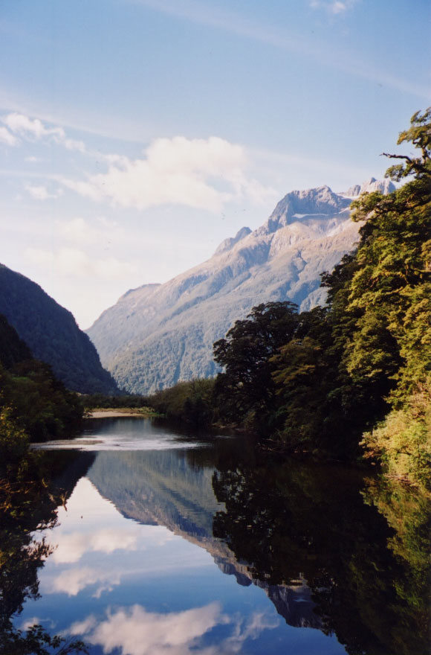
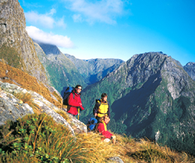
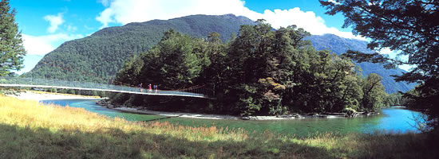
Last night, I watched the tri-nations test between South Africa and New Zealand which South Africa actually won by 21 -20. The All Blacks looked very lethargic and never seemed like winning – so much for the team that is supposed to be the best in the world at the moment! But most of the ABs woes resulted from just one player – who is actually a very good player. A casual pass be made was intercepted, resulting in SA’s first try. Later, NZ scored under the posts but the try was disallowed as this guy was penalised. Then with two minutes to go and NZ ahead 20 – 18, he was penalised again allowing SA to take and succeed with the penalty kick that won then the match. Apparently, there is a cup called the ‘Freedom Cup’ which NZ and SA play for in their 3-game Tri-nations encounters, which NZ had already one from its two previous encounters. However, the guy organising the presentation (a former Springbok captain – inset in photo) insisted it be presented to the SA captain. After this, it was presented to the rightful holder. Thus, the photos show the cup being awarded to the two captains!
While the test was being broadcast, there was a programme on another channel about NZ, which included the Milford track walk. I managed to see part of this. If I had known that the test was not going to be that interesting, I would have watched all of the Milford Track walk.

In Hong Kong, as mentioned above, schools have re-opened for the new school year. This is the first year of the ‘3-3-4’ system, i.e. 3 years lower secondary, 3 years upper secondary and 4 years university. Therefore, there will be only six years of secondary education compared with seven at present. The 5-day working week in gradually spreading. Some banks have adopted this but open on Saturday (?) and Sunday using additional staff.
The fish fiasco in HK continues! When using a copy of last year’s letter to write this one, I read it first before deleting the text. In that letter I was commenting about contaminated fish was China. Well, it has occurred again this week – and not once but twice! One case involved the use of malachite green, the same harmful substance that I was writing about last year. The other concerned fish fed with male hormones, which can also be very harmful. Finally, in HK, a ship repair dock leaked oil, wiping out large numbers of fish from nearby fish farms, just one day after the government had said sort of incident this would not happen!
Finally, in HK, there have been two fatal accidents in two days involving backing trucks killing pedestrians.
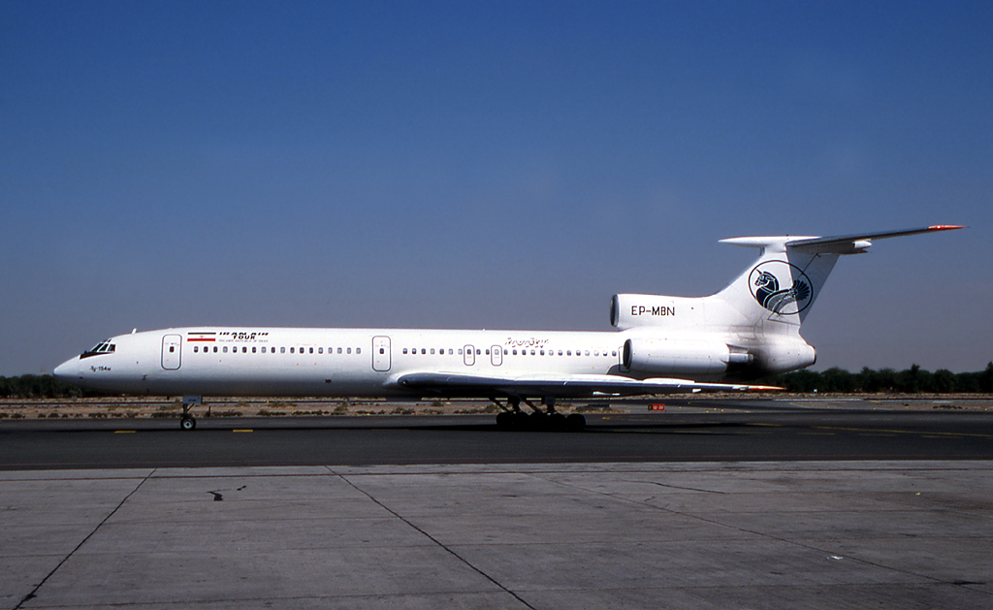
Another Russian built airliner, the TU-154, crashes, this time in Iran. This was the second case in as many weeks involving the same type of aircraft. Part of the reason given for this latest case is that the planes are in poor condition because sanctions on Iran mean it cannot get spare parts or purchase modern aircraft.
That seems to be it for now. More than I thought.

Cheers

